64  Snakes and Ladders | 63 | 62 | 61 | 60 | 59 | 58 | 57
49 | 50 | 51 | 52 | 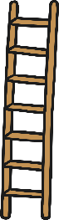  53 | 54 | 55 | 56
48 | 47 | 46 | 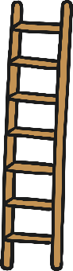  45 | 44 | 43 | 42 | 41
33 | 34 | 35 | 36 | 37 | 38 | 39 | 40
32 | 31 | 30 | 29 | 28 | 27 | 26 | 25
17 | 18 | 19 | 20 | 21 | 22 | 23 | 24
16 | 15 | 14 | 13 | 12 | 11 | 10 | 9
1 | 2 | 3 | 4 | 5 | 6 | 7 | 8
Create your own maths snakes and ladders.

