Name: ____________________________________

**‘ou’ words**

shout count house cloud proud found

1. I live in a ________________.
2. I lost my doll but later on I _______________ it again.
3. We do not _______________ at school.
4. When I see a dark _____________ in the sky I know it is going to rain.
5. We can _____________ in 1’s, 2’s and 10’s.
6. My teacher is always ______________ of me when I try my best.

Can you think of the opposite of these words ?

1. Whisper ________________
2. Lost ___________________
3. Sweet __________________
4. In ____________________
5. North _________________

What am I ?

1. I am a part of your body. You use me for talking, eating and

drinking. What am I ? _________________

**‘ou’ words**

Look at the picture clues. What ‘ou’ words are they showing ?

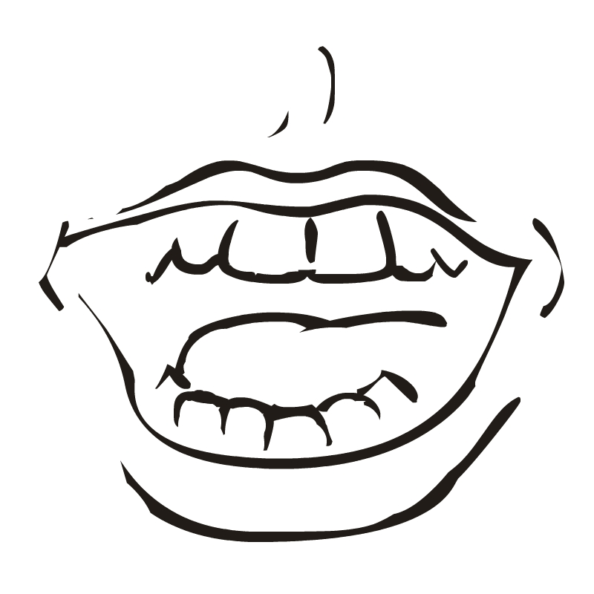

1. ____________ 2. ________________

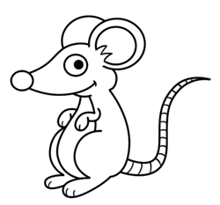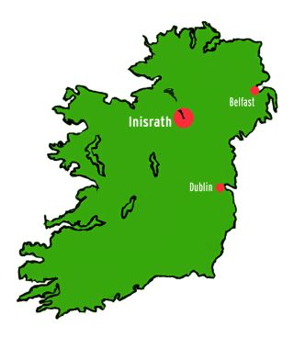

3._________________ 4.__________________

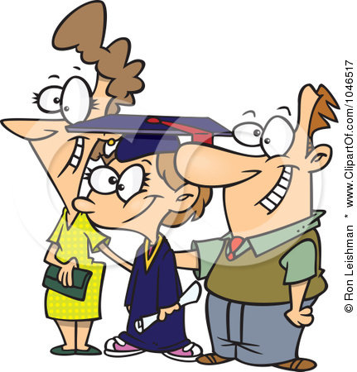

5.__________________ 6._________________

**Write a sentence about the ‘ou’ pictures.**

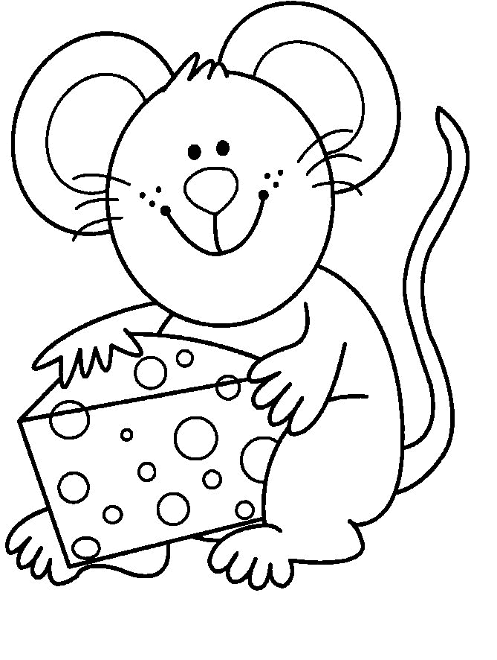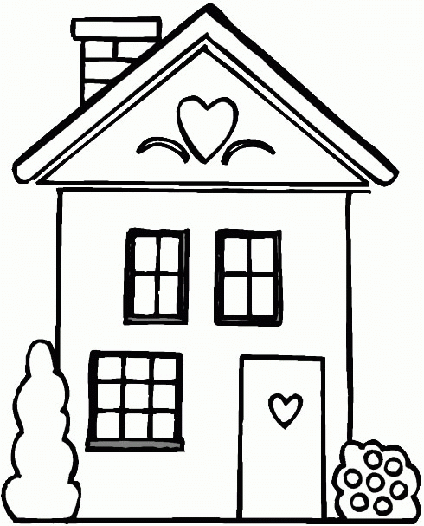

1._____________________________________________________

______________________________________________________

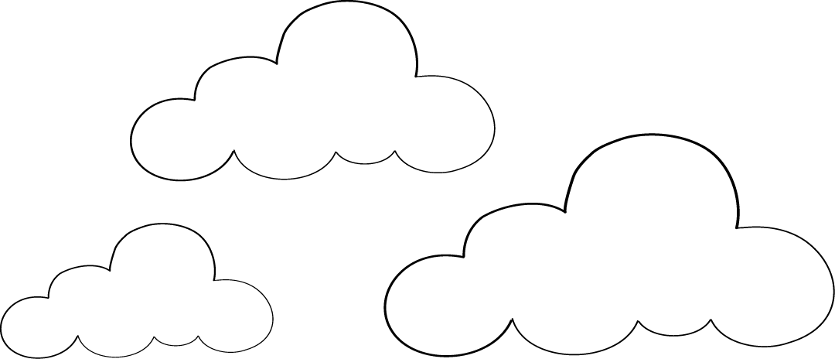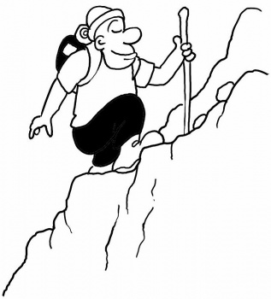

2._____________________________________________________

______________________________________________________

**Check:**

Capital Letters

Full stops

Spellings

Neat writing

I am happy with my work I can try harder



‘ou’ quiz

1.____________A building that people live in.

2.____________Musical instruments make this.

3.____________Not lost anymore.

4.____________The worm lives here.

5.____________Not in.

6.____________Belongs to us.

7.____________The county where we live.

8.____________When you have tried your best you feel ..........

9.____________A part of your body used for eating.

10. ___________The clock tells us the ......... of the day.

11. ___________Opposite of sweet.

hour sour Louth mouth ours

sound shout found

out house ground proud

12.___________To use a loud voice.

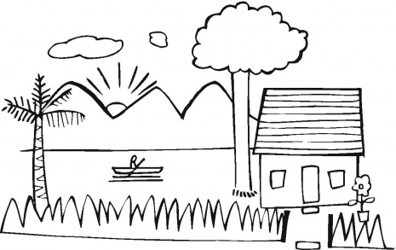

Lucy mouse lives in a lovely little house in County Louth. Every morning she walks outside and looks at the beautiful mountains behind her house. That is her favourite thing to do. She also looks up at the sky to see if it is a cloudy day. Lucy likes to count the clouds out loud but she never shouts.

Lucy loves to eat cheese too. One day she took a big piece of cheese out of the fridge. She went out for a walk and dropped the cheese on the ground. She lost it!!! Lucy walked around until she found it again. She was very proud that she had found it. She popped it into her mouth and it was very sweet and tasty.

