Name: Date:
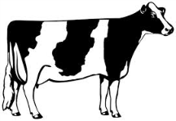
Missing Word Sentences
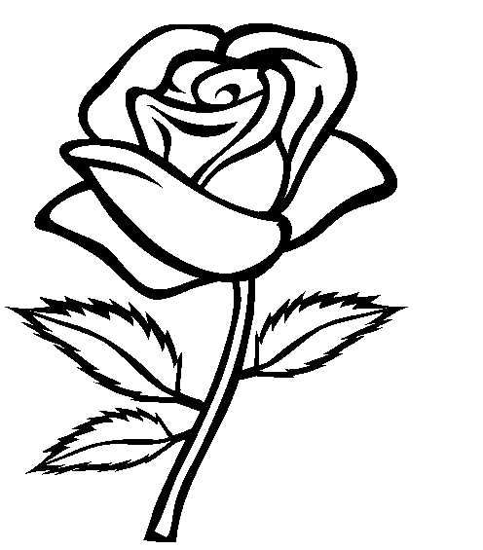
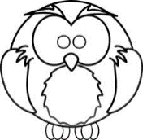
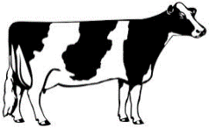
brown owl flower cows
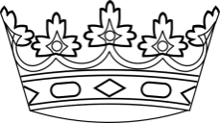
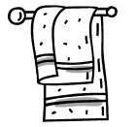
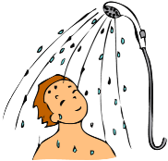
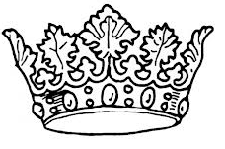
crowns shower towel down

- The teacher said, “Put your pencils _________!”
- On the farm there are chickens, sheep, pigs, and a lot of _________.
- My Mum loves it when I give her a _________.
- After playing sport I take a _________.
- After my shower I dry myself with a soft _________.
- The _________ is a very smart bird.
- The king and queen have gold and silver _________.
- Chocolate is a dark _________ colour.

